WHAT ARE YOU DOING THIS WINTER?

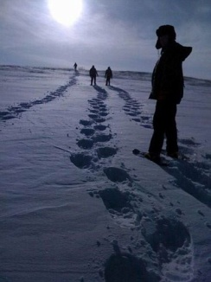
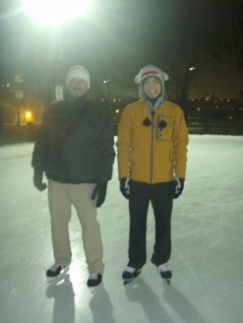
Are you tired of sitting around, flipping through TV channels, waiting for spring to arrive?
Do you want to have some fun, meet new friends, and have an adventure while exploring the Edmonton region?
Why not check out the Edmonton Outdoor Club!


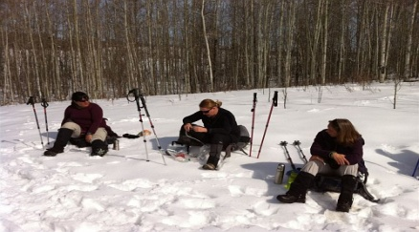
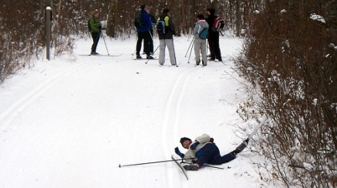

With your FREE membership, you can take part in:
Outdoor activities/sports: | Hiking, camping, backpacking, biking, canoeing, skiing, skating, snowshoeing, etc.
Social activities: | Parties, spectator sporting events, billiards, bowling, laser tag, movies, dinners, etc.

No experience? No problem! Most EOC events cater to those with minimal or no experience.

Visit our website and become our newest member! www.edmontonoutdoorclub.com

www.edmontonoutdoorclub.com | www.edmontonoutdoorclub.com | www.edmontonoutdoorclub.com | www.edmontonoutdoorclub.com | www.edmontonoutdoorclub.com | www.edmontonoutdoorclub.com | www.edmontonoutdoorclub.com | www.edmontonoutdoorclub.com | www.edmontonoutdoorclub.com | www.edmontonoutdoorclub.com | www.edmontonoutdoorclub.com | www.edmontonoutdoorclub.com | www.edmontonoutdoorclub.com | www.edmontonoutdoorclub.com | www.edmontonoutdoorclub.com | www.edmontonoutdoorclub.com | www.edmontonoutdoorclub.com | www.edmontonoutdoorclub.com | www.edmontonoutdoorclub.com | www.edmontonoutdoorclub.com | www.edmontonoutdoorclub.com | www.edmontonoutdoorclub.com | www.edmontonoutdoorclub.com | www.edmontonoutdoorclub.com | www.edmontonoutdoorclub.com | www.edmontonoutdoorclub.com | www.edmontonoutdoorclub.com | www.edmontonoutdoorclub.com | www.edmontonoutdoorclub.com | edmontonoutdoorclub.com | edmontonoutdoorclub.com | edmontonoutdoorclub.com | edmontonoutdoorclub.com | edmontonoutdoorclub.com | edmontonoutdoorclub.com | edmontonoutdoorclub.com | edmontonoutdoorclub.com | edmontonoutdoorclub.com | edmontonoutdoorclub.com | edmontonoutdoorclub.com | edmontonoutdoorclub.com | edmontonoutdoorclub.com | edmontonoutdoorclub.com | edmontonoutdoorclub.com | edmontonoutdoorclub.com | edmontonoutdoorclub.com | edmontonoutdoorclub.com | edmontonoutdoorclub.com | edmontonoutdoorclub.com | edmontonoutdoorclub.com | edmontonoutdoorclub.com | edmontonoutdoorclub.com | edmontonoutdoorclub.com | edmontonoutdoorclub.com | edmontonoutdoorclub.com

